# Software Design Principles Notes

Contents

Software Design Principles Notes 1

Aim of software design patterns: 2

State Design Pattern: 9

Key Participants: 9

**State:** 9

**Concrete State:** 9

**Context:** 10

Strategy Pattern: 13

Key Participants: 13

**Strategy:** 13

**Concept Strategy:** 13

**Context:** 13

Implementation with code: 14

Observer Pattern: 16

Key participants: 16

**Subject** 16

**Observer** 16

**ConcreteSubject** 16

**ConcreteObserver** 16

Implementation w/ code: 17

**Subject:** 17

**Observer:** 17

**CurrCondDisplay (Concrete Observer)** 17

**Weather Data (Concrete Subject)** 18

**Implementation for main programme:** 19

Iterator Design Pattern: 21

Key participants: 21

**Iterator:** 21

**Aggregate:** 21

**Concreate Iterator:** 21

**ConcreteAggregate:** 22

Implementation w/ Code: 22

**Iterator:** 22

Interface: 23

**Example Usage:** 23

Decorator Pattern: 24

Key Participants: 24

**Component:** 24

**ConcreteComponent:** 24

**Decorator:** 24

**ConcreteDecorator:** 25

Implementation with Code: 25

**Component:** 25

**ConcreteComponent:** 25

Decorator: 25

**ConcreteDecorator:** 26

Factory Method Pattern 27

Key participants 27

**Product** 27

**ConcreteProduct** 27

**Creator** 27

**ConcreteCreator** 27

Implementation w/ Code: 28

**Product:** 28

**ConcreteProduct:** 29

**Creator:** 29

**ConcreteCreator:** 30

Abstract Factory Design Pattern: 32

## Aim of software design patterns:

1. **Buildable** - can be implemented without error
2. **Maintainable** - can be updated relatively easily
3. **Extendable** - can add new features without affecting existing features unnecessarily
4. **Reusable** - can be ported over to other similar projects

**Cohesion:**

- Describes how much a component contributes to a **single** purpose

- Low cohesion -> more complex, changes are harder to implement, therefore harder to reuse

Hence we want **high** cohesion.

1. Operation cohesion
2. Class Cohesion
3. Specialisation Cohesion

**Coupling:**

- Describes the amount of **interconnections** between components

If components have high coupling:

1. Changes in one component likely to affect the other
2. Implementing af unctionaility may be more difficult as multiple components are involved
3. Harder to test the system, due to issues arising from multiple components
4. Inheritance Coupling  
   - Try to move attributes to sub classes if only required by one subclass, reduces the need for unnecessary inheritance of attributes
5. Interaction Coupling  
   - Try to have as few parameters as possible between messages in a sequence diagram

**State:**

- Current condition of an object

- Determined by:

1. Current value of the object’s **attributes**

2) **Links** it has with other objects

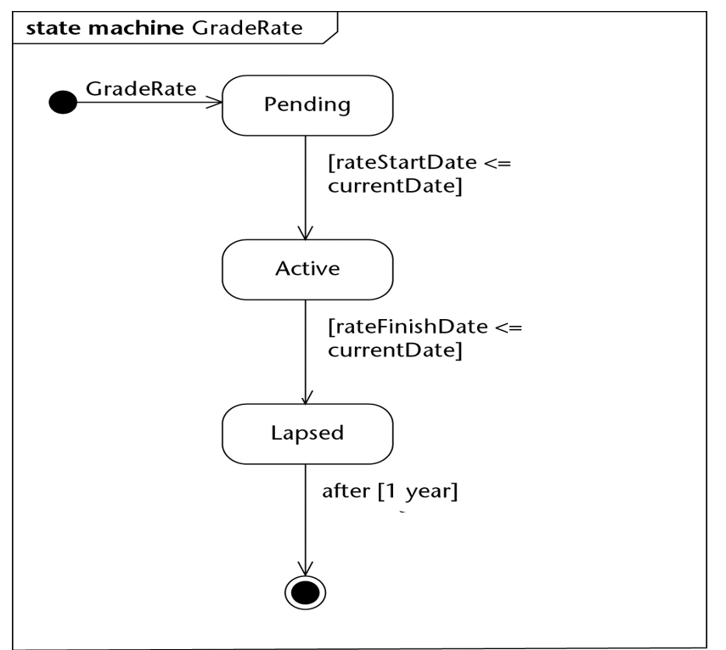

Types of trigger:

1. Change trigger

- Occurs when condition becomes true

1. Call trigger

- Occurs when an object recieves a call of one of its operations either from another object or from itself

1. Relative-Time trigger

- Caused by the passage of a designated period of time after a specified event (usually entry to the current state)

1. Signal Trigger

- Occurs when an object receives a signal (async communication)

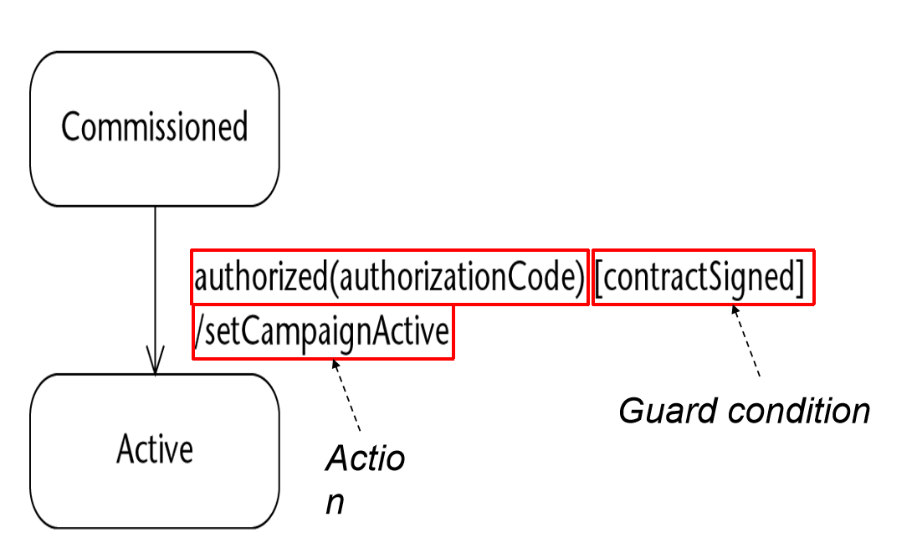

**Transitions:**  
- Transition is fired when following conditions are satisfied:

* Entity is in the state of the source state
* Event specified in label occurs
* Guard condition specified in the label is evaluated to be true

When a transition is fired, actions associated with it are executed

**Internal Activites:**

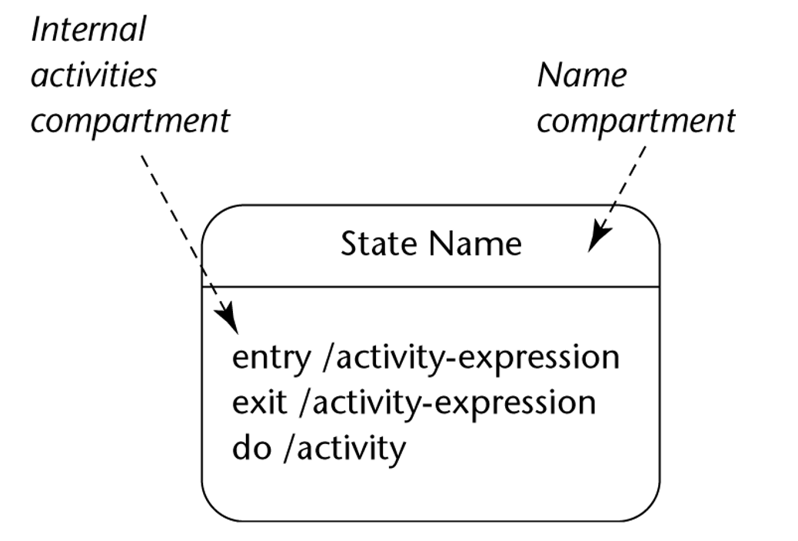

**UML Notation:**

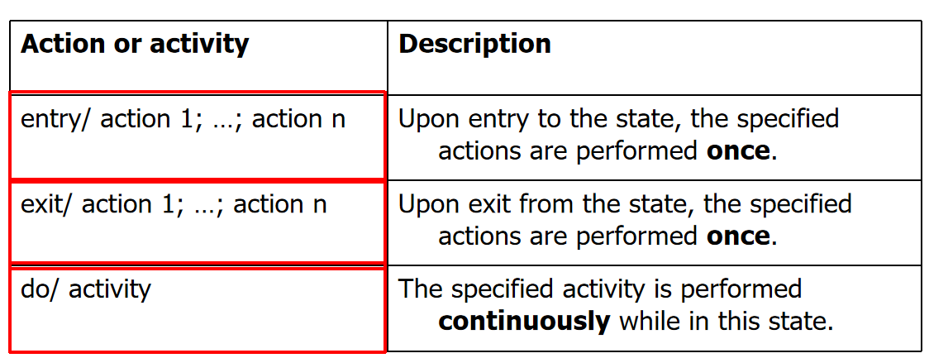

**Example:**

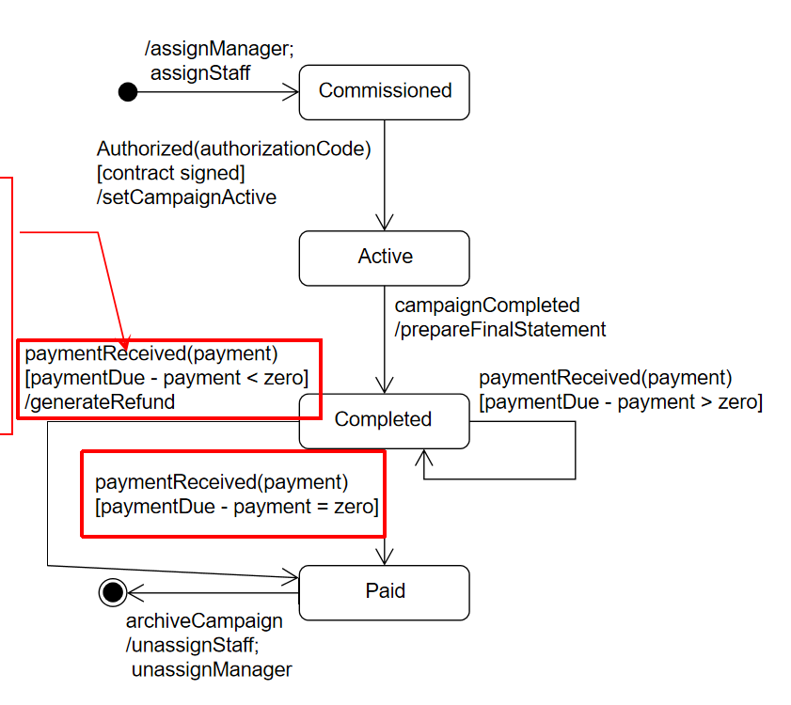

**Junction and Choice Psuedostates:**

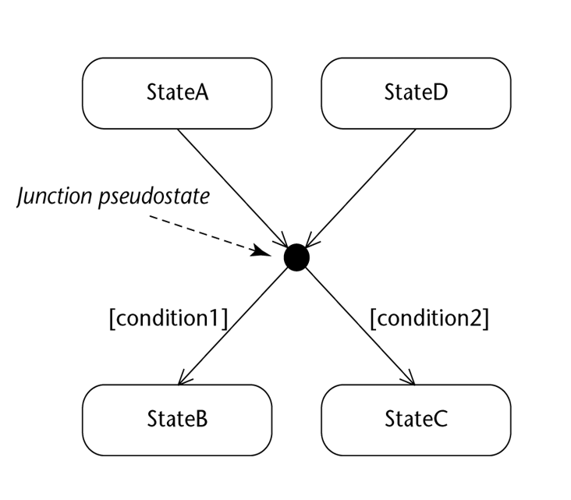

- UML says that object can end up in **any** resulting state if there is no priority, would result in ill-formed state machine

**Full State Machine Example:**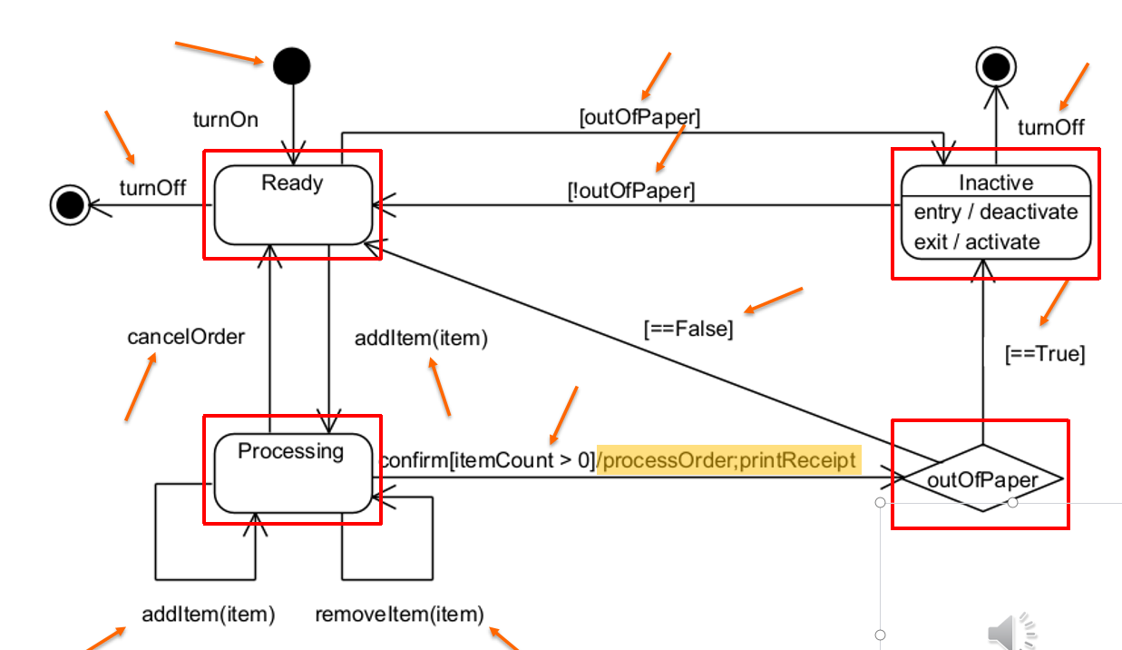

# State Design Pattern:

Allows an object to alter its behaviour when its internal state changes

The object will appear to change its class (a.k.a objects for states)

Applicability:

* Object’s behaviour depends on its state, must change it’s behaviour at runtime depending on that state:
  + Operations have large, multi-part conditional statements that depend on that state
  + Same conditional structure over many operations
  + State design pattern puts each branch in the conditional as a separate class -> each state is an object, can vary independentlyA computer screen shot of a diagram

    Description automatically generated

## Key Participants:

### **State:**

Defines an interface to encapsulate the behaviour of all states in the context

### **Concrete State:**

Implements the behaviour using the state interface

### **Context:**

Configures with state objects, maintains an instance to a ConcreteState object that represents its current state

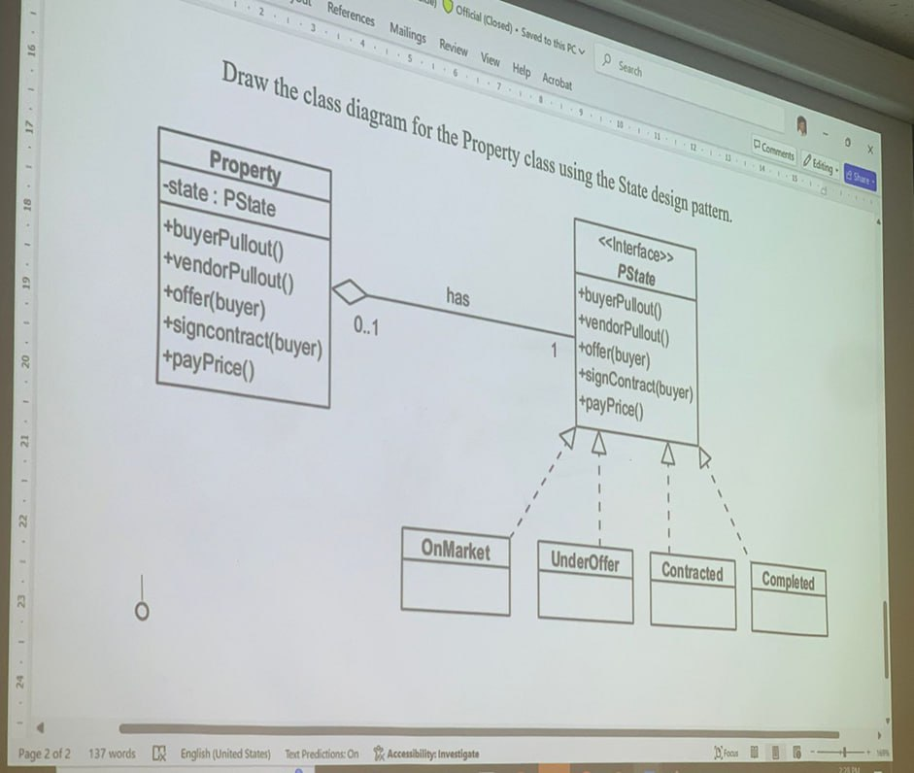

  public class Property

    {

        private PState _state;

        private bool _success = false;

        public Property()

        {

            _state = new OnMarket(); // Initial state

        }

        public void SetState(PState state)

        {

            _state = state;

        }

        public bool IsSaleSuccessful()

        {

            return _success;

        }

        public void MarkSaleSuccess()

        {

            _success = true;

        }

        public void BuyerPullout()

        {

            _state?.BuyerPullout(this);

        }

        public void VendorPullout()

        {

            if (_success)

            {

                Console.WriteLine("Vendor cannot pull out - sale is complete with success = True");

            }

            else

            {

                _state?.VendorPullout(this);

            }

        }

        public void Offer(Buyer buyer)

        {

            if (_success)

            {

                Console.WriteLine("Cannot offer - sale is complete with success = False");

            }

            else

            {

                _state?.Offer(this, buyer);

            }

        }

        public void SignContract(Buyer buyer)

        {

            _state?.SignContract(this, buyer);

        }

        public void PayPrice()

        {

            _state?.PayPrice(this);

        }

    }

-------

    public interface PState

    {

        void BuyerPullout(Property property);

        void VendorPullout(Property property);

        void Offer(Property property, Buyer buyer);

        void SignContract(Property property, Buyer buyer);

        void PayPrice(Property property);

    }

-------------

    public class OnMarket : PState

    {

        public void BuyerPullout(Property property)

        {

            Console.WriteLine("No buyer to pull out. The property is on the market.");

        }

        public void VendorPullout(Property property)

        {

            Console.WriteLine("Vendor pulls out. Sale is complete with success = False.");

            property.SetState(new Completed());

        }

        public void Offer(Property property, Buyer buyer)

        {

            Console.WriteLine("Offer made.");

            property.SetState(new UnderOffer());

        }

        public void SignContract(Property property, Buyer buyer)

        {

            Console.WriteLine("No buyer to sign contract.");

        }

        public void PayPrice(Property property)

        {

            Console.WriteLine("Contract not yet signed.");

        }

    }

# Strategy Pattern:

* Defines a family of algorithms, encapsulates each one and makes them interchangeable
* Algorithm may vary independently from the clients that use it
* Known as policy design

Applicability:  
- Sometimes there are many ways to achieve a task (such as payment)

* “Correct” way is dependent on circumstances
* Wish to change strategy used during runtime, or want to keep implementation details secret

## Key Participants:

### **Strategy:**

* Defines an interface common to all supported algorithms

### **Concept Strategy:**

* Implements the algorithm using Strategy Interface

### **Context:**

* Maintains a reference to a strategy object
* Configured with a ConcreteStrategy object
* May define an interface that lets Strategy access its data

**Example:**  
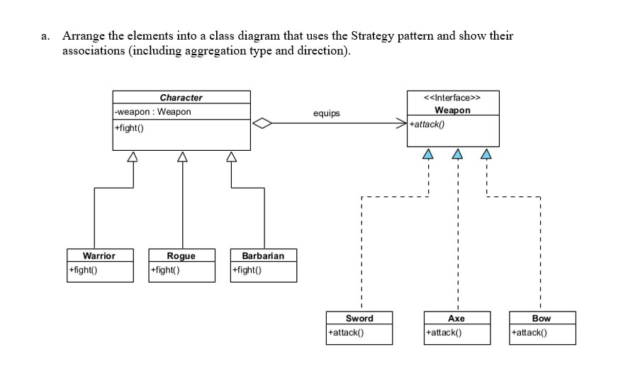

## Implementation with code:

 public abstract class Character

    {

        private Weapon _weapon;

        // Empty constructor

        protected Character()

        {

        }

        // Property for accessing and changing the weapon

        public Weapon MyWeapon

        {

            get { return Weapon; }

            set { Weapon = value; }

        }

        public Weapon Weapon { get => _weapon; set => _weapon = value; }

        // Abstract method to be implemented by subclasses

        public abstract void Fight();

    }

 // Warrior.cs

    public class Warrior : Character

    {

        public Warrior()

        { }

        public override void Fight()

        {

            MyWeapon?.Attack(); // Call Attack if MyWeapon is not null

        }

    }

----------------------

# Observer Pattern:

Defines a one-to-many dependency between objects, so when one object changes state, all its dependents are notified and updated immediately

## Key participants:

### **Subject**

* Provides interface to register/remove/notify observers

### **Observer**

* Defines interface for update notification

### **ConcreteSubject**

* Object being observed
* Sends notification to observers when state is changed

### **ConcreteObserver**

* Observing object
* Implements observer interface update() method

Example:

## Implementation w/ code:

### **Subject:**

// Subject interface with methods to register, remove, and notify observers

interface Subject

{

    void RegisterObserver(Observer o); // Register an observer

    void RemoveObserver(Observer o);   // Remove an observer

    void NotifyObservers();            // Notify all observers of a change

}

### **Observer:**

// Observer interface with an update method to receive state changes

interface Observer

{

    void Update(float temp, float humidity, float pressure); // Update the observer with new data

}

### **CurrCondDisplay (Concrete Observer)**

// Concrete observer implementation that displays current conditions

class CurrentConditionsDisplay : Observer

{

    private float temperature; // Store the temperature for display

    private float humidity;    // Store the humidity for display

    private float pressure;    // Store the pressure for display

    private Subject weatherData; // Reference to the Subject to allow deregistration if needed

    // Constructor registers itself as an observer of the provided Subject

    public CurrentConditionsDisplay(Subject weatherData)

    {

        this.weatherData = weatherData;

        weatherData.RegisterObserver(this);

    }

    // Update method called by Subject with new data

    public void Update(float temperature, float humidity, float pressure)

    {

        this.temperature = temperature;

        this.humidity = humidity;

        this.pressure = pressure;

        Display(); // Display updated data

    }

    // Display method to print the current conditions, including pressure

    public void Display()

    {

        Console.WriteLine("Current conditions: " + temperature + "F degrees, "

                          + humidity + "% humidity, and "

                          + pressure + " pressure");

    }

}

### **Weather Data (Concrete Subject)**

// Concrete implementation of the Subject interface

class WeatherData : Subject

{

    private List<Observer> observers; // List to hold observers that are watching this subject

    private float temperature;        // Current temperature data

    private float humidity;           // Current humidity data

    private float pressure;           // Current pressure data

    // Constructor initializes the list of observers

    public WeatherData()

    {

        observers = new List<Observer>();

    }

    // Register an observer by adding it to the observers list

    public void RegisterObserver(Observer o)

    {

        observers.Add(o);

    }

    // Remove an observer from the observers list

    public void RemoveObserver(Observer o)

    {

        observers.Remove(o);

    }

    // Notify all registered observers by calling their update method

    public void NotifyObservers()

    {

        foreach (Observer observer in observers)

        {

            observer.Update(temperature, humidity, pressure);

        }

    }

    // This method is called when the measurements change

    public void MeasurementsChanged()

    {

        NotifyObservers(); // Notify observers about the change

    }

    // Method to simulate new weather data and notify observers

    public void SetMeasurements(float temperature, float humidity, float pressure)

    {

        this.temperature = temperature;

        this.humidity = humidity;

        this.pressure = pressure;

        MeasurementsChanged(); // Call MeasurementsChanged to update observers

    }

}

### **Implementation for main programme:**

// Test program to demonstrate the Observer pattern

class WeatherStation

{

    static void Main(string[] args)

    {

        WeatherData weatherData = new WeatherData(); // Create the Subject

        // Create an observer and register it to receive updates from WeatherData

        CurrentConditionsDisplay currentDisplay = new CurrentConditionsDisplay(weatherData);

        // Simulate new weather measurements

        weatherData.SetMeasurements(80, 65, 30.4f);

        weatherData.SetMeasurements(82, 70, 29.2f);

        weatherData.SetMeasurements(78, 90, 29.2f);

    }

}

# Iterator Design Pattern:

Provides a way to access the elements of an aggregate object sequentially without exposing its underlying representation

* Loose coupling between client and aggregate/iterator classes

## Key participants:

### **Iterator:**

* Defines the interface for accessing and traversing elements
  + Next() advances to the next element and returns it as an Object
  + hasNext() returns true if there is another element in the aggregate, false otherwise

### **Aggregate:**

* Defines the interface for creating an iterator object

### **Concreate Iterator:**

* Implements the Iterator interface
* Keeps track of current position

### **ConcreteAggregate:**

* Implements the iterator creation interface to return an instance of ConcreteIterator

## Implementation w/ Code:

### **Iterator:**

class OddIterator : Iterator {

    List<int> values;

    int position = 0;

public OddIterator(List<int> values) {

    this.values = values;

    // Move position to first odd number, skip even numbers

    while ((position < values.Count) && (values[position] % 2 != 0)) {

        position++;

    }

}

public bool hasNext() {

    return position < values.Count;

}

public object next() {

    int value = values[position];

    position++;

    // Move position to next odd number, skip even numbers

    while ((position < values.Count) && (values[position] % 2 != 1)) {

        position++;

    }

    return value;

}

}

### Interface:

interface Iterator {

    public bool hasNext();

    public object next();

}

### **Example Usage:**

// Example usage

List<int> list = new List<int>();

list.Add(1);

list.Add(2);

list.Add(3);

// Create an iterator for odd numbers

OddIterator oddIterator = new OddIterator(list);

while (oddIterator.hasNext()) {

    Console.WriteLine((int)oddIterator.next());

}

# Decorator Pattern:

* Attaches additional responsibilities to an object dynamically
* Provides a flexible alternative to subclassing for extending functionality

## Key Participants:

### **Component:**

* Defines the interface for objects that can have responsibilities added to them dynamically

### **ConcreteComponent:**

* Defines an object to which additional responsibilities can be attached

### **Decorator:**

* Maintains a reference to a Component object
* Defines an interface that conforms to the Component

### **ConcreteDecorator:**

* Adds responsibilities to the component

## Implementation with Code:

### **Component:**

public abstract class Beverage {

    protected string description = "Unknown Beverage”;

    public virtual string getDescription() {

      return description;

    }

    public abstract double cost();

}

### **ConcreteComponent:**

public class HouseBlend: Beverage

{

    public HouseBlend() {

      base.description = "House Blend";

    }

    public override double cost() { return 4.50; }

}

public class DarkRoast: Beverage

{

    public DarkRoast() {

      base.description = "Dark Roast";

    }

    public override double cost() { return 4.00; }

}

### Decorator:

public abstract class CondimentDecorator: Beverage {

    public abstract override string getDescription();

}

### **ConcreteDecorator:**

public class Mocha: CondimentDecorator {

    private Beverage beverage;

    public Mocha(Beverage beverage) {

        this.beverage = beverage;

    }

    public override string getDescription() {

        return beverage.getDescription() + ", mocha";

    }

    public override double cost() {

        return 0.80 + beverage.cost();

    }

}

# Factory Method Pattern

* Defines an interface for creating an object, but lets the subclasses decide which class to instantiate
* Lets a class defer instantiation into subclasses

## Key participants

### **Product**

* Defines interface for objects that the factory method creates

### **ConcreteProduct**

* Implements the Product interface

### **Creator**

* Declares the factory method, which returns an object of type Product
* May also define a default implementation of factory method that returns a default ConcreteProduct

### **ConcreteCreator**

* Overrides the factory method to return ConcreteProduct

Example:

## Implementation w/ Code:

### **Product:**

abstract class Pizza

{

    public void Prepare()

    {

        Console.WriteLine($"Preparing {this.GetType().Name}");

    }

    public void Bake()

    {

        Console.WriteLine($"Baking {this.GetType().Name}");

    }

    public virtual void Cut()

    {

        Console.WriteLine($"Cutting {this.GetType().Name} in standard way");

    }

    public void Box()

    {

        Console.WriteLine($"Boxing {this.GetType().Name}");

    }

}

### **ConcreteProduct:**

class NYStyleCheesePizza : Pizza

{

    public override void Cut()

    {

        Console.WriteLine($"Cutting {this.GetType().Name} into traditional New York slices");

    }

}

class NYStyleHawaiianPizza : Pizza

{

    // Uses default Cut() implementation

}

class ChicagoStyleCheesePizza : Pizza

{

    public override void Cut()

    {

        Console.WriteLine($"Cutting {this.GetType().Name} into square slices (Chicago Style)");

    }

}

class ChicagoStyleHawaiianPizza : Pizza

{

    // Uses default Cut() implementation

}

### **Creator:**

abstract class PizzaStore

{

    // Factory method to create a pizza, implemented by subclasses

    protected abstract Pizza CreatePizza(string type);

    // Method to order a pizza

    public Pizza OrderPizza(string type)

    {

        Pizza pizza = CreatePizza(type);

        if (pizza != null)

        {

            pizza.Prepare();

            pizza.Bake();

            pizza.Cut();

            pizza.Box();

        }

        else

        {

            Console.WriteLine("Sorry, we don't have that type of pizza.");

        }

        return pizza;

    }

}

### **ConcreteCreator:**

class NYStylePizzaStore : PizzaStore

{

    protected override Pizza CreatePizza(string type)

    {

        if (type == "cheese")

        {

            return new NYStyleCheesePizza();

        }

        else if (type == "hawaiian")

        {

            return new NYStyleHawaiianPizza();

        }

        else

        {

            return null;

        }

    }

}

class ChicagoStylePizzaStore : PizzaStore

{

    protected override Pizza CreatePizza(string type)

    {

        if (type == "cheese")

        {

            return new ChicagoStyleCheesePizza();

        }

        else if (type == "hawaiian")

        {

            return new ChicagoStyleHawaiianPizza();

        }

        else

        {

            return null;

        }

    }

}

# Abstract Factory Design Pattern:

* Provides an interface for creating families of related or dependent objects without specifying their concrete classes

## Key participants:

### **AbstractFactory**

* Declares an interface for operations that create abstract product objects

### **ConcreteFactory**

* Implements the operations to create concrete product objects

### **AbstractProduct**

### Declares an interface for a type of product object

### **ConcreteProduct**

* Defines product object to be created by the corresponding concrete factory
* Implements the AbstractProduct interface

Example:

### **Abstract Factory:**

<Interface>

public interface IPizzaIngredientFactory

{

    IDough CreateDough();

    ITopping CreateTopping();

}

### **ConcreteFactory:**

public class NYPizzaIngredientFactory : IPizzaIngredientFactory

{

    public IDough CreateDough()

    {

        return new ThinCrustDough();

    }    public ITopping CreateTopping()

    {

        return new Pepperoni();

    }

}

public class ChicagoPizzaIngredientFactory : IPizzaIngredientFactory

{

    public IDough CreateDough()

    {

        return new ThickCrustDough();

    }    public ITopping CreateTopping()

    {

        return new Beef();

    }

}

### **Abstract Product:**

<Interface>

// Abstract Products

public interface IDough { }

public interface ITopping { }

### **ConcreteProduct:**

public class ThinCrustDough : IDough { }

public class ThickCrustDough : IDough { }

public abstract class Cheese : ITopping { }

public class ReggianoCheese : Cheese{ }

public class MozzarellaCheese : Cheese{ }

public class Pepperoni : ITopping { }

public class Beef : ITopping { }

**Client:**

**Differences between Factory Method and Abstract Factory**

* Factory Method
  + Uses subclasses that override a factory method
  + Creates a single object
* Abstract Factory
  + Uses object composition
  + Creates a family of objects